BOOKS IN BRIEF

Posted on October 18, 2012 by vvaposted
http://vvabooks.wordpress.com/2012/10/18/the-history-of-bearing-children-by-jacqueline-murray-loring/

The History of Bearing Children by Jacqueline Murray Loring

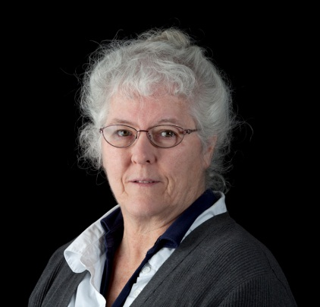

Jacqueline Murray Loring (above) is the editor of two important anthologies, Summer Home Review: A Community of Words: A Circle of Poets, An Anthology of Selected Poems and Stories (2002), and Summer Home Review, Volume II: A Community of Words: A Circle of Writers An Anthology of Poems, Prose, Plays and Translations (2005). The Summer Home Review books celebrate the experience of the William Joiner Center for the Study of War and Social Consequences at the University of Massachusetts, Boston.

There is fine poetry in these two anthologies, which includes works by Vietnam veterans David Connolly, Preston Hood, Gary Rafferty, Marc Levy, and many others. The books, Loring says, “trace the literary bonds of all the poets and the influences of their poet-teachers like Bruce Weigl, Fred Marchant, Yusef Komanyakaa, Lady Borton, W. D. Ehrhart, Lamont Steptoe and Martha Collins.”

This review focuses on Loring’s The History of Bearing Children (Quercus Publishing, $10.00, paper), a new slender and austere volume of her own poetry. It consists of thirty poems on forty-eight pages.

We are told in the Author’s Note that Loring lives on Cape Cod with her husband, Gary. Nothing is said there of her or Gary’s military service. A reader must find the dedication for more details. The book is dedicated to “my husband Gary Loring who served in the U. S. Army in Vietnam from 1967-1968, where he was stationed in Saigon and worked out of the 3rd MASH Hospital in Dong Tam, south of Saigon during the Tet Offensive, to Spec Todd W. Eastman, and to everyone who has been impacted by warring.”

That would be everyone on this planet. “Warring” is a new word to me in this context. To my ear it sounds a lot like “whoring.” I looked it up. “Two or more people or groups in conflict with each other.” That about covers it.

A partial list of war-related terms I gleaned from this small book follows. The list almost reads like a poem itself: Jungle foliage, enlisting, Army blankets, the South China Sea, warriors, battles, Gold Star tea, booby-traps, bamboo paper, Abu Graib, shrapnel, conscientious objector, SEAL, dog handler, grunt, Marine, war games, dog tags, flashbacks, about face, AWOL. Agent Orange, badge of courage, Army private, Edgewood Arsenal, battlefield, “the barrel of a gun,” war, crisp salute, Tet, flashbacks, death, napalm, Navy uniforms, box of medals, squadron.

These thirty poems carry a heavy freight of martial language, and they do the task gracefully and with elegance.

The poem :”Agent Orange” whispered most powerfully to me because I’m dying of Agent Orange-provoked multiple myeloma, which is directly related to the thirteen-and-a-half months I spent basking in the sunshine in South Vietnam in 1966 and 1967. The words that stuck in my brain are these: “Bones withered like the trees poisoned from the sky.” Loring is writing about me and my cancer-ridden bones. She has never met me, and very likely has never heard of me.

Buy this small, powerful book and read these poems. Become more aware of how all-inclusive the butcher’s bill of war is.

To get a copy of the book or for more information send an email to jmljake@capecod.net
The mailing address is: J.M. Loring, PO Box 338, Monument Beach, MA 02553.
The website is http://www.capecodwriters.net/

—David Willson

